

INSTITUTO POLITÉCNICO
NACIONAL
ESCUELA SUPERIOR DE CÓMPUTO

INSTRUMENTATION

PRACTICE 2:
Use of Resistive Sensors

GROUP:
3CV2

TEACHER:
ISMAEL CERVANTES DE ANDA

STUDENTS:
ADAN CARDENAS, ANDREA ABIGAIL
ROMERO ORTEGA, CHRISTIAN
BRAVO TORRES, ALEJANDRO

09/02/2019

Practice Objective:
During the lab practice we may understand how resistive transducers works, and how they can be used with a Wheatstone bridge. It’s necessary to understand how resistive transducer works because with them we may measure many measurement units like a tool measurement does.

Practice Introduction:
First, we need to understand some basic concepts about fundamental parts of the practice.
A Wheatstone bridge is an electrical circuit used to measure an unknown electrical resistance by balancing two legs of a bridge circuit, one leg of which includes the unknown component.

A potentiometer is a three-terminal resistor with a sliding or rotating contact that forms an adjustable voltage divider. If only two terminals are used, one end and the wiper, it acts as a variable resistor.

A thermistor is a type of resistor whose resistance is dependent on temperature, more so than in standard resistors. The word is a portmanteau of thermal and resistor.
An operational amplifier (often op-amp) is a DC-coupled high-gain electronic voltage amplifier with a differential input and, usually, a single-ended output. In this configuration, an op-amp produces an output potential that is typically hundreds of thousands of times larger than the potential difference between its input terminals.
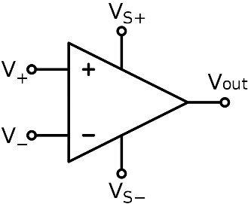
Pin configuration:
- V+: non-inverting input
- V−: inverting input
- Vout: output
- VS+: positive power supply
- VS−: negative power supply
Other types of differential amplifier include the fully differential amplifier (similar to the op-amp, but with two outputs) and the instrumentation amplifier (usually built from three op-amps).
A voltage follower (also called a unity-gain amplifier and a buffer amplifier) is an op-amp (operational amplifier) circuit which has a voltage gain of 1. This means that this op amp does not provide any amplification to the signal. The reason it is called a voltage follower is because the output voltage directly follows the input voltage, meaning the output voltage is the same as the input voltage. Thus, for example, if 10V goes into the op amp as input, 10V comes out as output. A voltage follower acts as a buffer, providing no amplification or attenuation to the signal.

Voltage Followers are Important in Voltage Divider Circuits
Another reason why voltage followers are used is because of their importance in voltage divider circuits. This again deals with ohm's law. According to ohm's law, voltage= current x resistance (V=IR).
In a circuit, voltage divides up or is allocated according to the resistance or impedance of components.
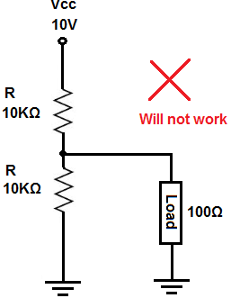
The above circuit will not work, and it will be explained now why not. In the circuit above, we have a voltage divider between the top 10KΩ resistor and the bottom 10KΩ and 100Ω resistors in parallel. The voltage divider equation is characterized by the following equation, 10KΩ and 10KΩ||100Ω.
Doing the math across the 10KΩ and the 100Ω resistors in parallel gives us, 10KΩ || 100Ω = (10KΩ) (100Ω)/1.1KΩ= 99.01Ω ~ 99Ω.
So, we next have a voltage divider between the 10KΩ resistor and the 99Ω resistor.
We now can use the voltage divider formula to see how much voltage will fall across the top 10KΩ resistor and the bottom 10KΩ resistor in parallel with the 100Ω resistor.
The voltage divider formula for the voltage across the top 10KΩ resistor is, V= 10V(10KΩ)/(10KΩ+99Ω) = 9.9V.
The voltage divider formula for the voltage across the bottom 10KΩ resistor and the 100Ω resistor is, V= 10V(99Ω)/(10,099Ω) = 0.098V or 98mV.
Now let's say the load needs about 5V to operate. You can see based on the calculation, there will not be enough voltage at the output. As we calculated, we had 98mV as our voltage across the load at the output.
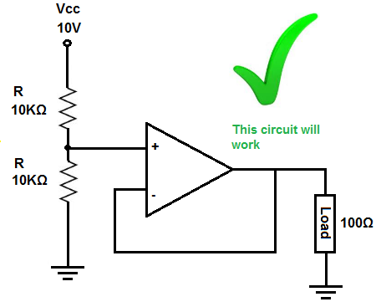
Let's see how this circuit changes now with an op amp, with its high input impedance, and the load connected to the output of the op amp.
The circuit above now works.
The voltage divider is now between the top 10KΩ resistor and the 10KΩ resistor and op amp at the bottom.
The op amp virtually offers infinite input impedance (obviously, it's not infinite in real life). Let's assume it's 100MΩ, though it can be much more.
The equation that would characterize our voltage divider is between, 10KΩ and 10KΩ || 100MΩ.
Doing the math on parallel resistance of the 10KΩ || 100MΩ resistance gives, (10KΩ) (100MΩ)/ (10KΩ + 100MΩ) = 9999Ω ~ 10KΩ.
Any voltage divider composed of the same 2 resistances gives half the voltage of the power supply. But just to show the math, we have the voltage divider formula, 10V * (10KΩ)/ (10KΩ + 10KΩ) = 5V. As we can notice 5 volts falls across the top 10KΩ resistor and 5V falls across the bottom 10KΩ resistor and the 100Ω, because of the 100Ω and 10KΩ resistor are in parallel both receive the same 5V.

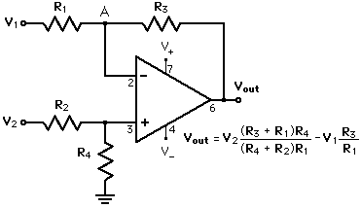
Differential Amplifier
The difference amplifier shown in the above circuit is a combination of both inverting and non-inverting amplifiers. If the non-inverting terminal is connected to ground, the circuit operates as an inverting amplifier
Usually for a differential amp, R3 = R4 and R1 = R2.
In that case the coefficients for V1 and V2 are equal and is V1=V2 (definition of common mode signal) then the output will be zero.
But if there is mismatch between R1 and R2 or between R3 and R4 then the coefficients are different and you get a non zero output when V1=V2. The output value/V1 is the common mode rejection ratio. Usually it is small for tight- toleranced resistors and can be expected to be about -60 dB (around 1/1000th) when resistors are matched to +/-0.1%

Practice Development:

In part one we needed to build a Wheatstone bridge, but this time instead of using a potentiometer or variable resistor a thermistor was used, the reason was that thermistor will change it resistance value by the time we light the fire close of it. As a result of this, the resistance was going to affect the voltage divisor giving us a change in the output voltage number two, which was expected to occur in order to see the changes at the second part of the circuit.

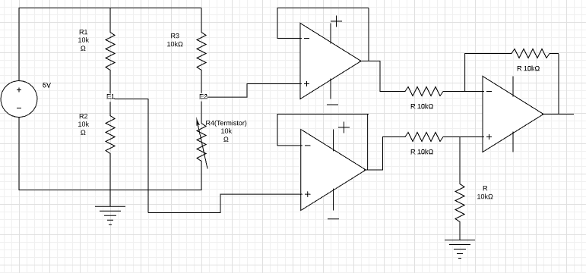
Circuit 1

Once we had finished putting together circuit one we started the making off instrumentation amplifier (second part). As we could see at the introduction the instrumentation amplifier is made of two voltage followers which outputs will be connected into an operational amplifier. The operational amplifier´s output will be the result of the voltages difference, and the voltage follower´s inputs are the output voltages from part one. As soon as we light the fire the thermistor voltage increments and voltage number two falls.

Table 1. Calculated
Temperature  (ºC) | E1(V) | E2(V) | E1-E2(V) | Vsal (V) | ∆R (Ω) | R_sen (Ω)
91.700 | 2.500 | 0.047 | 2.453 | 2.4539 | -9905.108 | 94.892
81.500 | 2.500 | 0.093 | 2.407 | 2.4007 | -9810.267 | 189.733
76.000 | 2.500 | 0.202 | 2.298 | 2.2865 | -9578.991 | 421.009
74.700 | 2.500 | 0.304 | 2.196 | 2.1799 | -9352.641 | 647.359
70.700 | 2.500 | 0.383 | 2.117 | 2.0982 | -9170.457 | 829.543
67.800 | 2.500 | 0.466 | 2.034 | 2.0087 | -8972.210 | 1027.790
66.300 | 2.500 | 0.565 | 1.935 | 1.9322 | -8726.043 | 1273.957
61.500 | 2.500 | 0.782 | 1.718 | 1.7525 | -8146.041 | 1853.959
60.700 | 2.500 | 0.830 | 1.670 | 1.6833 | -8009.592 | 1990.408
58.800 | 2.500 | 0.922 | 1.578 | 1.5674 | -7739.088 | 2260.912
56.100 | 2.500 | 1.083 | 1.417 | 1.4211 | -7235.129 | 2764.871
51.500 | 2.500 | 1.365 | 1.135 | 1.1262 | -6244.842 | 3755.158
46.000 | 2.500 | 1.675 | 0.825 | 0.8395 | -4962.406 | 5037.594
43.700 | 2.500 | 1.792 | 0.708 | 0.7079 | -4413.965 | 5586.035
38.100 | 2.500 | 2.049 | 0.451 | 0.4554 | -3056.591 | 6943.409
30.600 | 2.500 | 2.326 | 0.174 | 0.18563 | -1301.421 | 8698.579
29.040 | 2.500 | 2.355 | 0.145 | 0.1587 | -1096.408 | 8903.592
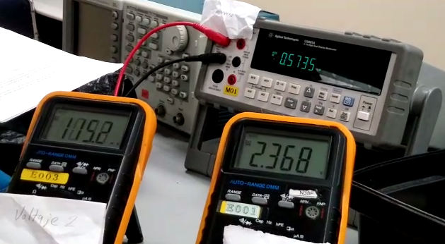

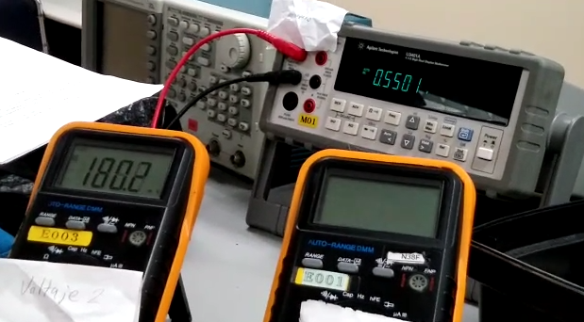

At part number three a differential amplifier was made using the same input voltage, and we could prove the formula shown at the picture because as soon as we light the fire close of the thermistor the output value started to change. Than was because thermistor took place instead of resistor 3.
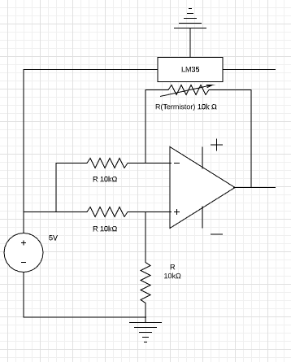

Table 2. Calculated
Temperature  (ºC) | Vsal (V) | ∆R (Ω) | R_sen (Ω)
30.54 | 0.719 | 2876.000 | 12876.000
33.44 | 1.0334 | 4133.600 | 14133.600
43 | 0.9144 | 3657.600 | 13657.600
48.6 | 1.1479 | 4591.600 | 14591.600
51.4 | 1.2452 | 4980.800 | 14980.800
55.2 | 1.415 | 5660.000 | 15660.000
60.4 | 1.5402 | 6160.800 | 16160.800
64.5 | 2.0587 | 8234.800 | 18234.800
70.7 | 1.8377 | 7350.800 | 17350.800
78.5 | 1.9928 | 7971.200 | 17971.200
84.7 | 2.1099 | 8439.600 | 18439.600
85.8 | 2.1327 | 8530.800 | 18530.800

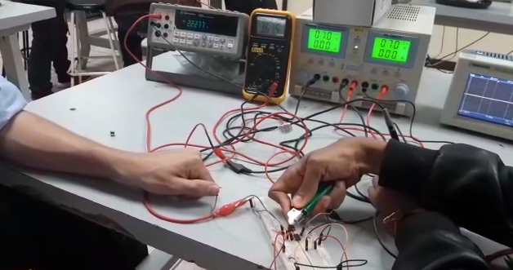

Questionaire
- Say what differences the circuits that were used in this practice have.
For circuit 1 we have an arrangement that implements the Wheatstone Bridge in its first stage, through which, the voltage reading is obtained through resistance variation, a set of OpAmps are used as voltage followers and substractors, to "clean" the parasitic resistance of our measurements.
On the other hand, in Circuit 2, we have an arrangement with an OpAmp that gives us a voltage measurement, by varying the gain, or controlled gain, by varying the resistance of the sensor in the negative feedback of the OpAmp.

- Which of the circuits is most advantageous to use? Why?
Circuit no.2, due to its easy construction, its operating range is very similar, its sensing is effective and low cost.

- How else can measurements be made?
There are at least two usual ways of measuring, with 2 and 4 wires, however, with 2 wires, there are many measurement errors, then we would consider the Kelvin or Four-terminal sensing method.
This method, developed by Lord Kelvin in 1861 [8], is the method used in many ohms and impedance analyzers and consists of using different cables for excitation with the current source and for measurement, so that the voltage drops produced in contacts and in the cables themselves will not be measured by the device. Fig. 1. Separation of current and voltage electrodes eliminates the lead and contact resistance from the measurement.
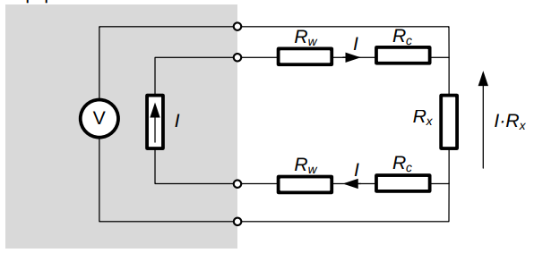Figure 1: Four-terminal sensing

- To measure the temperature inside an oven, what transducer would you use?
We could occupy one similar to that of Circuit No.2, with the implementation adjustments, materials and calibration necessary; or by implementing a sensor through a thermocouple. [9]

Simulations:

Circuit No.1
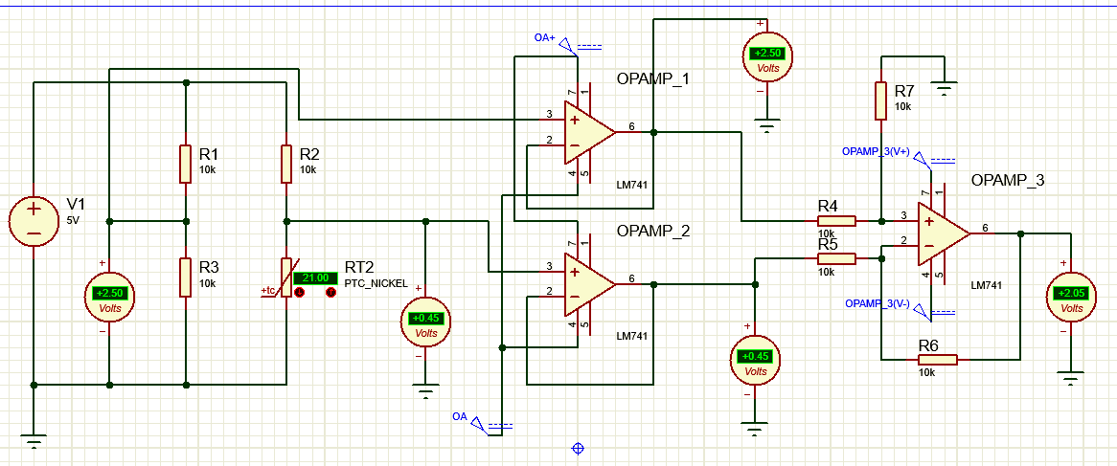

Temperature  (ºC) | E1(V) | E2(V) | E1-E2(V) | Vsal (V) | ∆R (Ω) | R_sen (Ω)
90.00 | 2.500 | 0.05 | 2.43 | 2.45 | -9905.108 | 0094.8
70.00 | 2.500 | 0.46 | 2.34 | 2.07 | -8972.210 | 1000.70
50.00 | 2.500 | 1.65 | 1.15 | 1.12 | -6244.842 | 3055.18
30.00 | 2.500 | 2.26 | 0.74 | 0.13 | -1301.421 | 8608.59
25.00 | 2.500 | 2.55 | 0.15 | 0.17 | -1096.408 | 8900.59

Circuit No.2
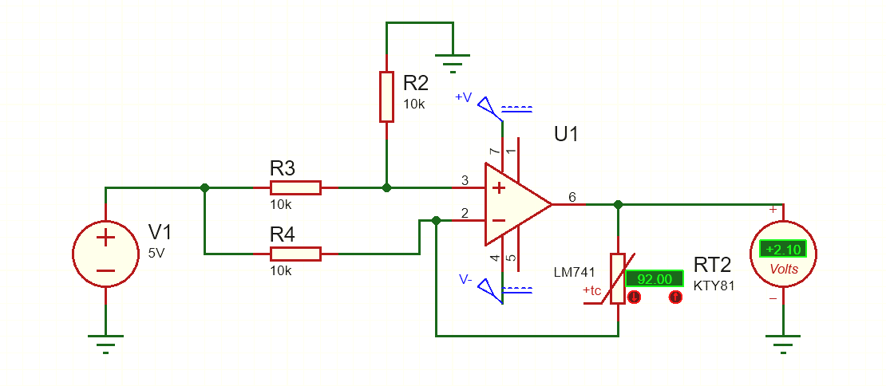

Temperature  (ºC) | Vsal (V) | ∆R (Ω) | R_sen (Ω)
30.00 | 0.79 | 2264.00 | 11786.623
50.04 | 1.52 | 4528.62 | 13880.623
70.07 | 1.77 | 7823.36 | 14520.345
90.80 | 2.27 | 8574.84 | 17432.823

Sources of information:
https://en.wikipedia.org/wiki/Wheatstone_bridge
https://en.wikipedia.org/wiki/Potentiometer
https://en.wikipedia.org/wiki/Thermistor
http://www.learningaboutelectronics.com/Articles/Voltage-follower
https://www.allaboutcircuits.com/textbook/semiconductors/chpt-8/building-a-differential-amplifier/
https://www.quora.com/What-will-be-the-CMRR-for-a-differential-amplifier
https://hetpro-store.com/TUTORIALES/amplificador-diferencial/
[8] https://www.academia.edu/29112469/Electrical_Conductivity_and_Resistivity
[9] Ioffe, Abraham F.: Semiconductors thermoelements and thermoelectric cooling. Infosearch Ltd., 1956.
http://www.infoagro.com/instrumentos_medida/doc_termometro.asp?k=62
https://en.wikipedia.org/wiki/Thermocouple
https://es.wikipedia.org/wiki/Detector_de_calor

